Attentive man

v 0.1
(platform to perform tasks - Facebook)

Realized by Viktor Litvak
(group B15, Vinnitsya IT-Academy)

2016

CONTENTS

1. System requirements ...............................................................................3
2. About "Attentive man" ...........................................................................3
3. User guide .................................................................................................3
4. Programmer instruction .........................................................................6
5. About author ............................................................................................8

- System requirements

  - PC or laptop.
  - Windows XP or later.
  - Processor 1.8 GHz or higher.
  - RAM 512 Mb or higher.
  - 15 Mb free space on HDD.
  - Internet connection up to 1 Mb/sec.
  - Mozilla Internet browser.
  - Installed cUrl library 7.48.0.
  - Installed OpenSSL 1.0.2g. (The easiest way to do it through the Cygwin)

- About "Attentive man" v0.1

[Attentive man] is a programmer product for automatically placing likes on your Facebook page. You can do likes on all your posts per one click on button. Also you can remove all likes the same way. The program shows total number of posts on your page, id_number of each post and number of actions taken.

- User guide

If you want to utilize "Attentive man" v0.1 program you should have Facebook account on the Internet. If you don't have it you can sign up by the link https://www.facebook.com/. Then you should follow the next steps:
  - Get users Facebook access_token:
  - Open Mozilla Firefox and follow link Facebook Api Explorer.
  - Enter your registration data (e-mail and pass) and sign in.
  - Press inverted triangle on "Get Token" button
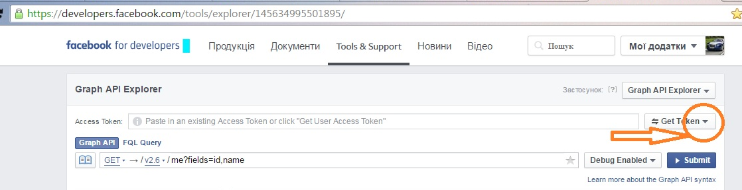

  - Press Get User Access Token.
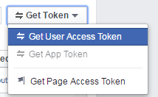

  - Choose next permissions :
    - publish_actions;
    - user_posts;

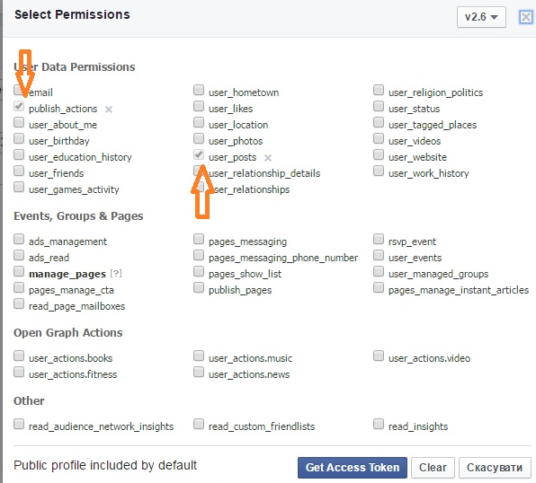

  - Press "Get Access Token"
  - Next window shows your access_token (SSH key);
  - Enter to the field "Graph Api" command "/me" and press "Submit"

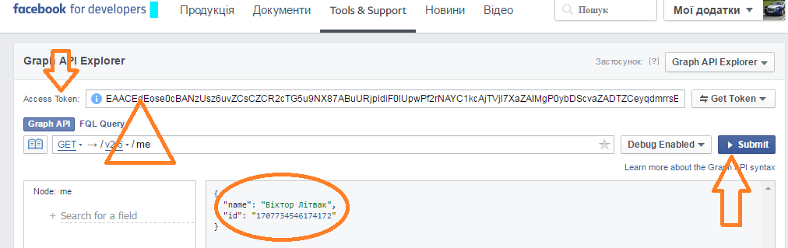

You got the user_id and access_token. They will need you to next steps.

  - Get example cUrl POST request on your Facebook page:
- Open Mozilla browser, find and add "Firebug" application

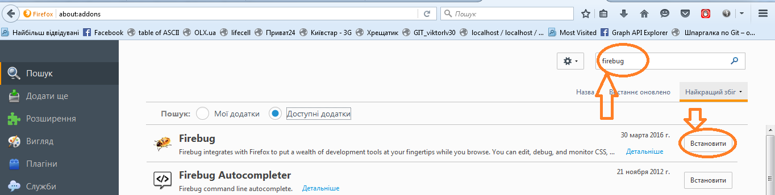

- Move to [Network->JavaScript] menu and press "Clear"
- In browser follow the link facebook.com and log in.
- Go to your page and press LIKE button under any post.
- In the Firebug window you can see POST with title [POST ?dpr=1]

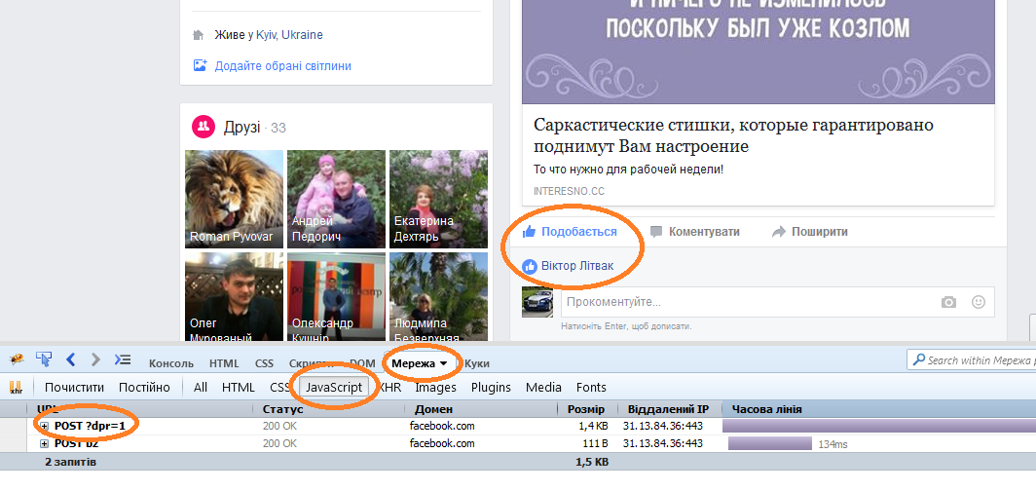

- Right-click a request and choose menu item "Copy as cUrl"

You got cUrl POST request. It will be utilizing for placing "Like" on all your posts.

  - Makes "Like"
- Run the application [Attentive man] v0.1 and log in.
- Press "Like" menu and choose "Open Window Like".
- Insert the user_id and access_token in appropriate fields (that your got from first menu item)
- Insert example cUrl POST request in the "cUrl command from Mozilla through the Firebug " (that your got from second menu item)
- Press "GET your posts" button. Info window shows all your posts on your Facebook page and its id_number. Counter shows quantity of posts.
- If you want placing "Like" all your posts you should press [LIKE] button.
- If you want to remove all likes - you should press [DISLIKE] button.
- Count below shows quantity of actions taken.
- Info Window shows posts id what was liked or disliked.

- Programmer instruction

  - IDE benefits (Qt-creator 5.5.1)
The application wrote in Qt-creator IDE v.5.5.1. This IDE has many its own classes ready for work with network, strings, sockets, processing different formats networks replay. For correctly work [Attentive man] you should write in your %PATH% directory way to the Qt’s libraries. (for example c:\Qt\Qt5.5.1\5.5\mingw492_32\bin\) . If you haven’t Qt IDE on your PC you should install it.
Qt-creator is a cross platform IDE, that is why you can build this program in Linux system. But you need change one command in the project – “system” for work with cUrl library in Linux. The same way you can do it for Android.

  - [Attentive man] v0.1 consists of:
- cores and widgets
core gui webkit webkitwidgets network script widgets
- ten header files
config.h \
MainWindowContainer.h \
FBApi.h \
HttpClient.h \
UT.h \
lib_json/json_batchallocator.h \
lib_json/json_internalarray.inl \
lib_json/json_internalmap.inl \
lib_json/json_valueiterator.inl \
likewindow.h
- nine *.cpp files
main.cpp \
MainWindowContainer.cpp \
FBApi.cpp \
HttpClient.cpp \
UT.cpp \
lib_json/json_reader.cpp \
lib_json/json_value.cpp \
lib_json/json_writer.cpp \
likewindow.cpp
- two UI forms
fbapi_gui.ui \
likewindow.ui
- also included next path for work with JSON:
. lib_json/include lib_json/include/json
  - Main classes, methods, slots and variables:

All of them are collected in “config.h” and “likewindow.h” files.
Main classes:
Table 1. – Main classes of Attentive man program v0.1.
Class Name | Description
class MainWindowContainer : public QMainWindow | included all main methods and variables of program. Main container of application
class LikeWindow | included all methods and variables for work with “Like”
class FBApi | included all needed variables for authorization, POST, GET and other request
class HttpClient: public QObject | included all needed methods for work with network
class UT | class for convert different system indicators to Qt native classes and configure application

Main methods are:
Table 2. – Main methods of Attentive man program v0.1.
Method Name | Description
class FBApi::
static FBApi* getInstance() | initialize current session
class LikeWindow : public QWidget
char* takeInfoFromCUrlCommand(  const QString source,  const char* marker) | choose from example cUrl POST request all needed parameters of future system “curl” command
char* createCUrlLink(  const QString ,  const char* ,  const char* ,  const char* ,  QStringList::iterator,  bool isLike,  const char*); | Create right cUrl link (command) from different parts

Main slots are:
Table 3. – Main slots of Attentive man program v0.1.
Slot Name | Description
class LikeWindow::

void on_RequestButton_clicked() | Public slot creates the necessary links and sends GET request to Facebook. It gets id of all posts in your page and show it at the Info Window
void requestFinished() | Get replay from Facebook when request is finished in JSON format. Parse this replay and create three containers with post’s Name, users ID number and post’s ID number.
void on_LikeButton_clicked() | Create Like command and send it into Facebook in cycle
void on_DislikeButton_clicked() | Create Dislike command, send it and remove all likes on your Facebook page

Main variables are:
Table 4. – Main variables of Attentive man program v0.1.
Variable Name | Description
QString FBApi::EMAIL | You can write default e-mail
QString FBApi::PASSWORD | You can write default password
QString FBApi::GENERAL_API_URL ="https://graph.facebook.com" | General url Facebook Graph API Explorer for get user_id number and access_token in Facebook for developer page
QUrl LikeWindow::url | Formed link into Graph API Explorer to get info about all your posts.
QNetworkAccessManager  LikeWindow::*mpQNman | Create your personal network access manager for Internet
QStringList LikeWindow::strPosts_id | List with user’s ID and post’s ID in QString format
QStringList LikeWindow::nextPagePosts | List of links of next page with your posts on Facebook (one replay can return not more than 25 posts ID. If your page has more than 25 posts, Facebook returns in JSON link to the next page with next 25 posts and so on).
QStringList LikeWindow::myPostIdList | List has only ID numbers all your posts on Facebook.

- About author

This project was realized by Viktor Litvak, student of Vinnitsya IT Academy, 2016. Frunze st. 4, Vinnitsya, Ukraine, 21020 (+380 97 94-715-94).

